

# NATIONAL UNIVERSITY OF SCIENCES AND TECHNOLOGY

SCHOOL OF MECHANICAL AND MANUFACTURING ENGINEERING

MECHANICAL ENGINNERING (ME-15)

# PROGRAMMING:

Home task #1

**SUBMITTEED BY: MUHAMMAD ALI SHOUKAT**

**REGISTRATION NUMBER: 457397**

DATE OF SUBMITTION: 4th of October, 2023

#include<iostream>

#include<cmath>

using namespace std;

int main(){

* Task #1

.

// int a=6;

// int b=5;

// int c=4;

// int d=3;

// int e=2;

// int f=1;

// cout<<"factorial of 6 is ";

// cout<<a*b*c*d*e*f;

// return 0;

//

**Output:**

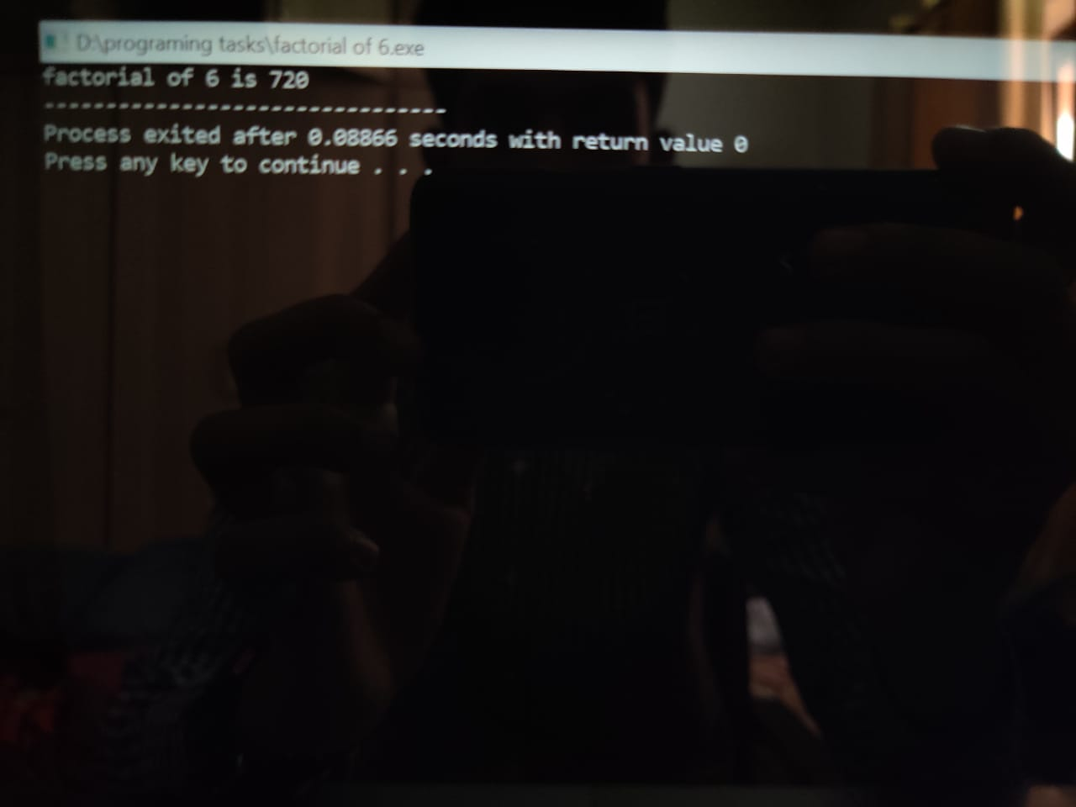

* Task #2.

// float a;

// cin>>a;

// cout<<"the value of x2 is "<<a<<endl;

// float b;

// cin>>b;

// cout<<"the value of x1 is "<<b<<endl;

// float c;

// cin>>c;

// cout<<"the value of y2 is "<<c<<endl;

// float d;

// cin>>d;

// cout<<"the value of y1 is "<<d<<endl;

// cout<<"the distance between two points is "<<sqrt((a-b)*(a-b))+((c-d)*(c-d));

// return 0;

**Output:**

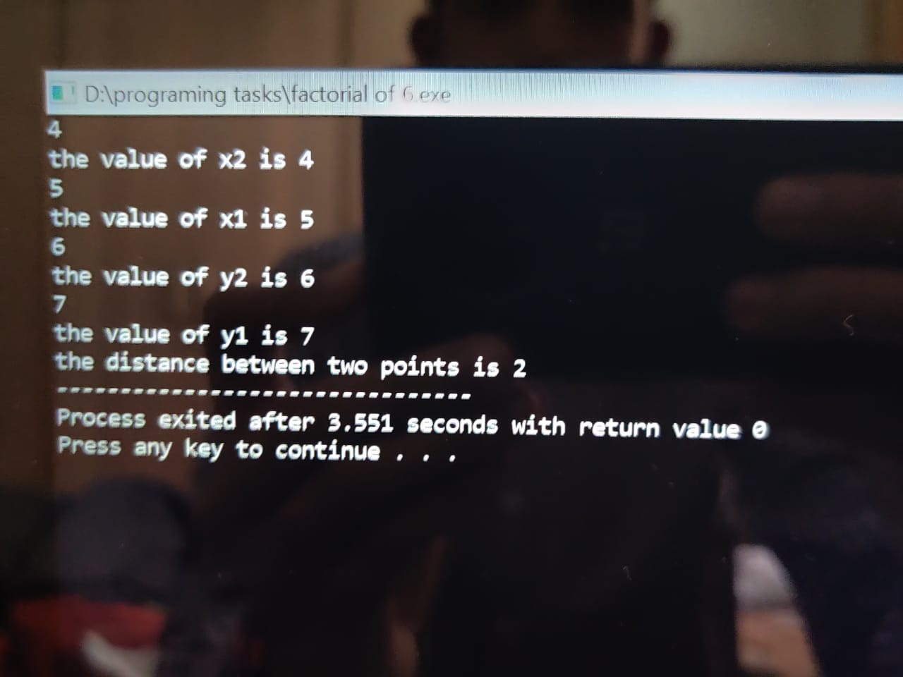

* Task #3.

// float nust;

// cin>>nust;

// cout<<"the value in cm to be converted in m and km is "<<nust<<endl;

// cout<<"the value in m is ";

// cout<<(nust/100)<<endl;

// cout<<"the value in km is ";

// cout<<(nust/100000);

// return 0;

**Output:**

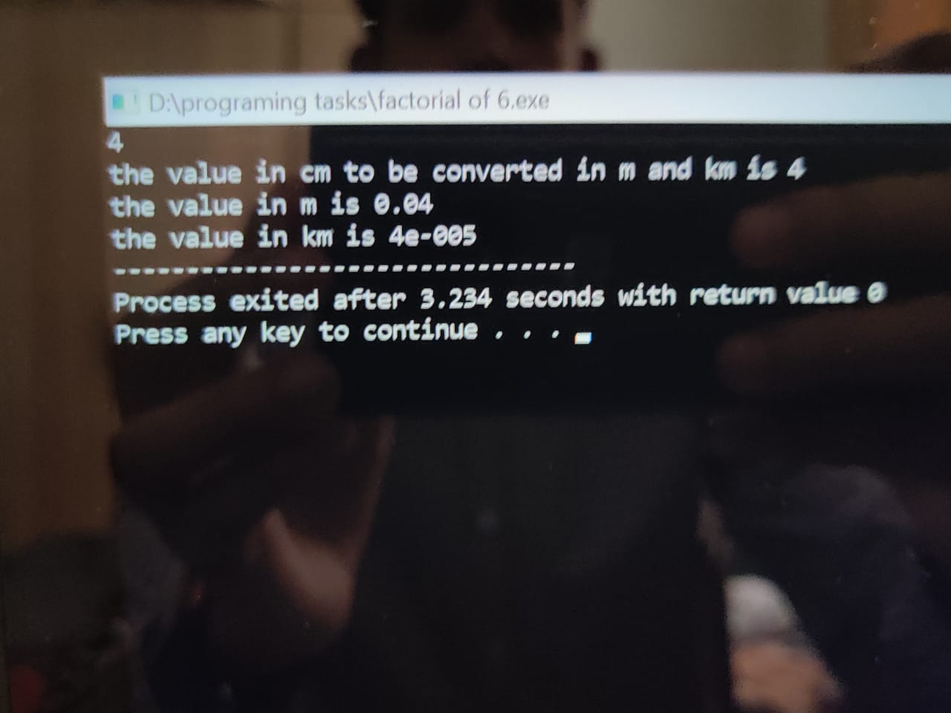

* Task #4.

// int x;

// cin>>x;

// cout<<"the value of a is "<<x<<endl;

// int y;

// cin>>y;

// cout<<"the value of b is "<<y<<endl;

// cout<<"the value of a2+2ab+b2 is ";

// cout<<(x+y)*(x+y);

// return 0;

//

//

}

**Output:**

